- Write equivalence partitioning (EP) test cases for the phone number input field in a Zomato-style food order form, where the field must accept exactly 10 digits and no letters or special characters.
Ans=>
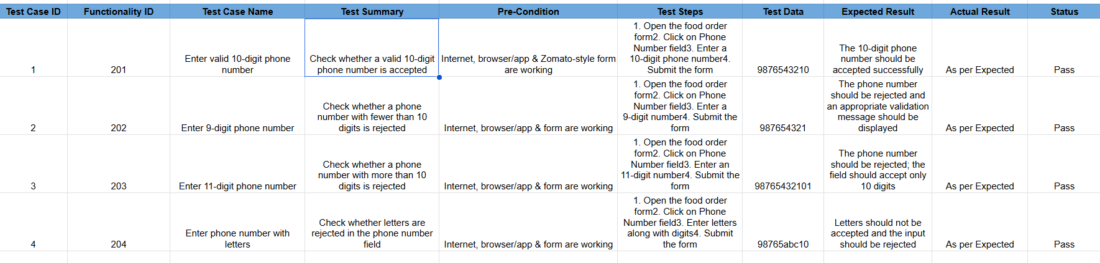

- For a Flipkart-style sign-up form with a password field that must be 8-16 characters long, write boundary value analysis (BVA) test cases to check the minimum, just above minimum, maximum, and just above maximum password lengths.<br><br><em><strong>Hint:</strong> Consider test cases for 7, 8, 9, 15, 16, and 17 characters.</em>
Ans=>
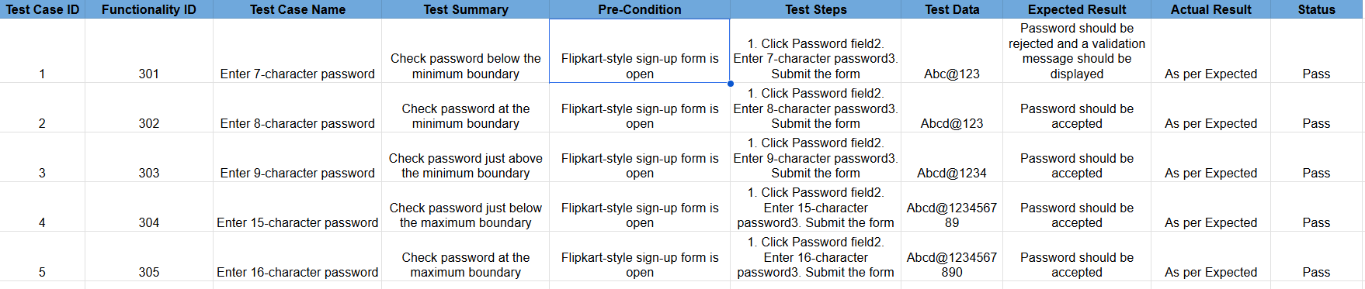

- Given an Instagram-like post creation form with a caption input that allows up to 2200 characters, use equivalence partitioning to identify valid and invalid input ranges and write at least 3 test cases for each partition.
Ans =>
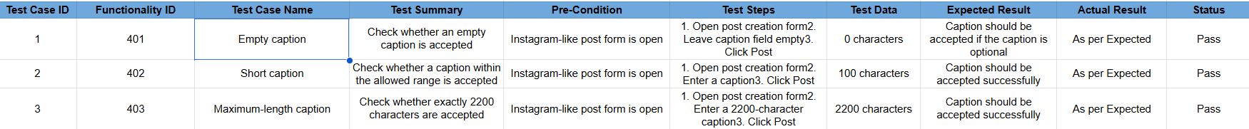

4.
For a BookMyShow movie ticket booking form with a 'number of tickets' field (allowed: 1 to 10), write BVA test cases to ensure the field correctly handles edge values.
Ans=>
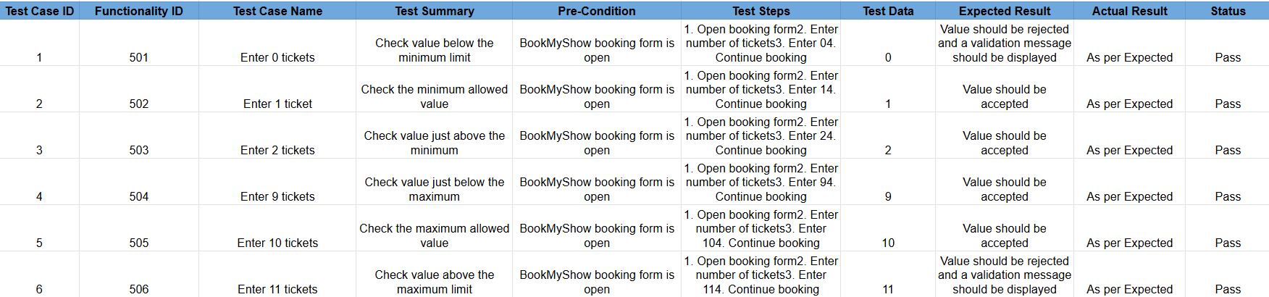

5. Pick any app you use daily (such as Paytm, Myntra, or IRCTC) and select one form field (e.g., amount, pincode, age). Write both equivalence partitioning and boundary value analysis test cases for that field, explaining your reasoning for each.
Ans=>
